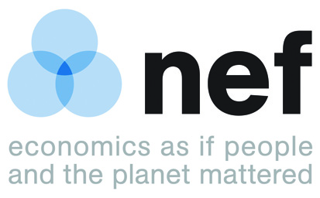
Embargoed until: 00:00 on 11.07.14

Contact: Aniol Esteban / Fernanda Balata, NEF (New Economics Foundation)
M: 07951 648 914 (Aniol) / 07969 050 524 (Fernanda)
e: Aniol.esteban@neweconomics.org Fernanda.balata@neweconomics.org

EU out of fish for 2014
From Friday onwards Europeans will be eating fish from outside their own waters
Research conducted by the New Economics Foundation (NEF) reveals the extent to which EU countries rely on fish from outside their waters to maintain their high levels of fish consumption.
- If the EU were only to consume fish from its own waters, it would run-out of fish on 11 July.
- The EU is still dependent on non-EU fish to support around 48 per cent of its fish consumption.
- The levels of “fish dependence” have become stable over the past years halting the negative trend of the past decades; but they remain disproportionately high.
- Restoring 43 fish stocks above a biomass where they can produce their maximum sustainable yield would move the EU’s fish dependence day to 85 days later in the year, on 4 October.
- The potential improvement in restoring 43 fish stocks is more than twice the size of the current external catches by the EU fleet, or more than half of the entire EU fish import deficit.

The 2014 update of NEF’s Fish Dependence report has found that, despite its potentially abundant and productive seas, about one out of every two fish consumed in the EU is sourced from non-EU waters. This means that Europeans are eating more fish than its seas produce and continue to miss on the huge economic benefits that would result from letting fish stocks grow.
EU remains Fish Dependent
Although the EU’s fish dependence day has moved later in the calendar by six days since 2008 – meaning a slight decrease in the EU’s reliance on fish from abroad – it is still three weeks earlier and the EU is therefore more dependent on external seafood sources than in 2000. The fact that levels of dependence are not increasing could be seen as a sign that overfishing is easing in EU waters. However, a recent report by the European Commission shows that the number of overfished stocks in the North East Atlantic, as well as the extent of overfishing, has increased between 2013 and 2014. This is a step backwards from the trend between 2007 and 2013, when the same region had seen a reduction in the number of overfished stocks.
Implementing the new Common Fisheries Policy
Despite having some of the largest and richest fishing grounds in the world, the EU also has some of the unhealthiest. European fisheries are still very far from where it should be.

The EU needs to focus efforts on restoring its own marine ecosystems and to move towards consumption levels that fit within ecosystem capacity. The newly reformed EU Common Fisheries Policy (CFP) is an opportunity to deliver healthier fish stocks, properly managed in the public interest and to reduce EU levels of fish dependence. Better managed fish stocks in Europe would deliver significant benefits to society in terms of food, revenue and jobs. Restoring EU fish stocks could support up to 100,000 more jobs and enough fish to feed 100 million EU citizens a year.
EU member states need to look beyond the short-term costs of fish stock restoration and turn the potential long-term benefits that healthy marine resources can provide into a reality.

Fernanda Balata from the New Economics Foundation said:
EU fish stocks are heavily overfished, meaning they deliver less fish than if they were above levels capable of producing their maximum sustainable yield, and yet fish consumption throughout Europe remains high. Latest figures by the European Commission show that EU decision makers have a lot of work to do to end overfishing in EU waters.”

“Following last year’s reform of the Common Fisheries Policy, Member States must now take the opportunity to realise the benefits of managing our marine ecosystems in the best interest of society, through ambitious fisheries management plans that lead to rapid fish stock restoration and quota allocation strategies that work in the public interest.”

- ENDS -
For more information or to arrange an interview please contact
Contact: Aniol Esteban / Fernanda Balata, NEF (New Economics Foundation)

m: 07951 648 914 (Aniol)
07969 050 524 (Fernanda)

e: Aniol.esteban@neweconomics.org
Fernanda.balata@neweconomics.org
Click here to download a full version of the report (PDF, 974KB)
Click here to download NEF’s briefing “Sustainable fisheries make economic sense”

Notes to editors:

About NEF
The New Economics Foundation (NEF) is an independent think-and-do tank that inspires and demonstrates real economic well-being. We aim to improve quality of life by promoting innovative solutions that challenge mainstream thinking on economic, environment and social issues. We work in partnership and put people and the planet first.
www.neweconomics.org

Figure 1 - EU catches and imports 1999-2011 (tonnes live weight)

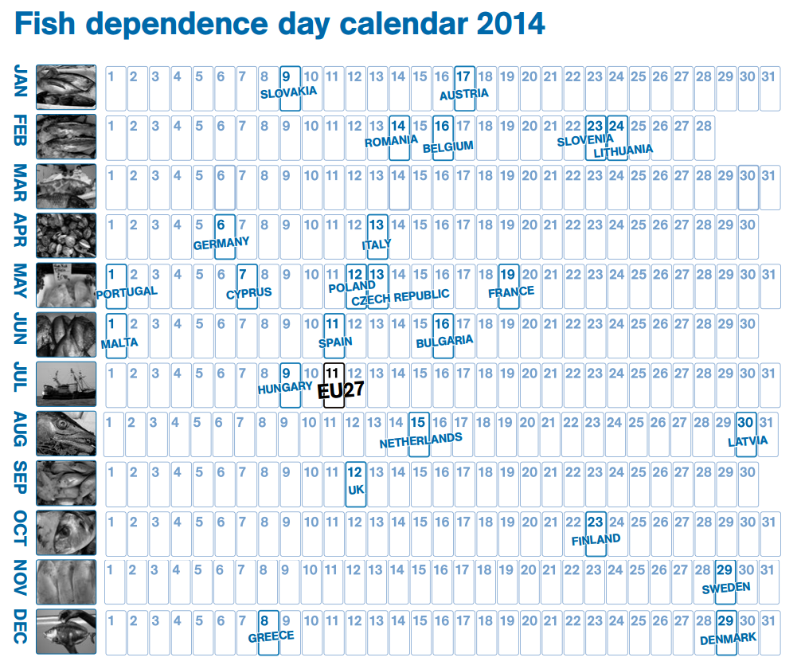

Table 1: Fish Consumption per capita for EU countries

Source: FAO Statistics Division (Updated: 29 June 2012)
http://faostat.fao.org/site/610/default.aspx#ancor

Fish dependence: Executive summary

European Union (EU) fish stocks are heavily overfished, which means they deliver far fewer fish than if they were allowed to recover; yet fish consumption throughout Europe remains high.

The EU has been able to maintain high levels of consumption by sourcing fish from other regions of the world, both through the catches of its distant-water fleet and through imports. This report highlights Europe’s reliance on fish products originating from external waters for its fish supplies, and provides pointers towards a more sustainable future for dwindling global fish stocks.

The New Economics Foundation (NEF) has estimated the degree of self-sufficiency in fish consumption achieved by the EU as a whole and for each of its EU27 member states; self-sufficiency is defined as the capacity of EU member states to meet demand for fish from their own waters. We have expressed the degree of self-sufficiency in the form of a ‘fish dependence day’. Based on a member state’s or a region’s total annual fish consumption, the fish dependency day is the date in the calendar when it will start to depend on fish from elsewhere because its own supplies have been depleted.

For the EU as a whole, fish dependence day is now 11 July, indicating that almost one-half of fish consumed in the EU is sourced from non- EU waters. Last year, it was 8 July; the year before, it was 6 July. The EU has therefore maintained a high degree of reliance on fish from non-EU waters, with its fish dependence day consistently falling in early July. The EU’s fish dependence is still three weeks earlier than in 2000 and has only moved later in the calendar by six days since 2008. Whilst it is still too early to say, we hope the fact that levels of dependence are not increasing marks a change in the trend and a sign that overfishing is diminishing in EU waters. All else being equal, this would manifest itself as improving self-sufficiency. Currently, however, the level of EU self-sufficiency is too low and the degree of overexploitation in EU waters too high.

Restoring 43 out of 150 stocks in the North-East Atlantic to their maximum sustainable yield would increase the EU’s self-sufficiency levels by almost three months (85 days), moving its fish dependence day to 4 October. If directed only to human food consumption, rebuilding European stocks could provide for the annual consumption of 100 million EU citizens.

Member states with little or no access to EU waters, such as Austria, Slovakia, and Slovenia, evidently become fish dependent early in the year. More surprising, however, is that many member states with greater access to EU waters are also fish dependent early in the year. These include Spain, Portugal, Italy, Germany, and France – all of whom source more than half of their fish from non-EU waters.

Our calculations include domestic aquaculture (fish farming) in EU countries, a growing global enterprise that has served to offset the overexploitation of EU fish stocks but has not itself been responsible for reversing the trend in fish dependence that has taken place over the past years. Nonetheless, if we discount domestic aquaculture, the EU’s fish dependence day moves earlier in the calendar to 25 May; for big aquaculture producers such as Spain, Italy, and Greece, their respective national fish dependence day would occur more than two months earlier.

Similarly, restoring EU fish stocks would result in significant gains in self-sufficiency levels. In a context of finite resources and growing populations, this EU model has proven unsustainable. The EU’s high levels of fish dependence have implications for the sustainability of fish stocks globally, which are also overfished, and for the communities that depend on them. The main message of this report is that rising fish consumption in a context of overexploited stocks is environmentally unviable and socially unfair. The EU has highly productive waters that have the potential to sustain a long-term and stable supply of fish, jobs, and related social and economic benefits, but only if its fish resources are managed responsibly.

We have started to see some positive signs in fish stocks recovery but are still very far from where we should be. The newly reformed EU Common Fisheries Policy (CFP) represents a significant step in the right direction as it lays the foundations that could eventually lead to sustainable management of fish stocks in Europe. The policy also includes a discard ban, and requires member states to be transparent and take social and environmental criteria into account when allocating fishing opportunities. The new CFP will be supported by the new European Maritime and Fisheries Fund (EMFF), which, whilst far from perfect, contains some positive measures, such as more funding to enhance data collection and improve control and enforcement. It is now up to EU member states to choose how ambitious they want to be in implementing the reformed CFP and how quickly they move to restore fish stocks to their maximum sustainable yield (MSY). Healthy fish stocks mean more food, more jobs, and higher profits, so the sooner we get there the better for everyone. EU member states need to look beyond the short-term costs of fish stock restoration and turn the potential long-term benefits that healthy marine resources can provide into a reality.

